 | National Curriculum Objective (Statutory) | By the end of the year, children should be able to… | National Curriculum Objective (Non- statutory) | Example
3 | Add and subtract numbers with up to three-digits, using formal written methods of columnar addition and subtraction | NB: Children should cross off exchanged numbers as they complete the calculation.  Numbers exchanged to the bottom when completing addition calculations.  Numbers crossed off and exchanged into previous place value column in subtraction calculations. | Pupils use their understanding of place value and partitioning, and practise using columnar addition and subtraction with increasingly large numbers up to three digits to become fluent | 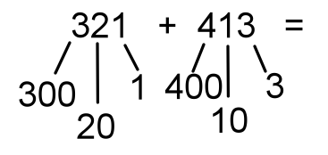  Explore exchange across place value columns.
4 | Add and subtract numbers with up to four- digits using the formal written methods of columnar addition and subtraction where appropriate | NB: Children should cross off exchanged numbers as they complete the calculation.  Numbers exchanged to the bottom when completing addition calculations.  Numbers crossed off and exchanged into previous place value column in subtraction calculations. | Pupils continue to practise both mental methods and columnar addition and subtraction with increasingly large numbers to aid fluency | Inclusive of decimals where appropriate.
5 | Add and subtract whole numbers with more than four-digits, including using formal written methods (columnar addition and subtraction) | NB: Children should cross off exchanged numbers as they complete the calculation.  Numbers exchanged to the bottom when completing addition calculations.  Numbers crossed off and exchanged into previous place value column in subtraction calculations. | Pupils practise using the formal written methods of columnar addition and subtraction with increasingly large numbers to aid fluency  AND  Solve problems involving addition, subtraction, deciding which operation to use to solve each problem | Inclusive of decimals where appropriate.  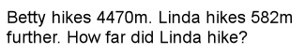
6 | Pupils use their knowledge of the order of operations to carry out calculations involving the four operations  AND  Solve addition and subtraction multi-step problems in contexts, deciding which operations and methods to use and why | 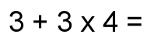  As year 5 and:  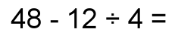  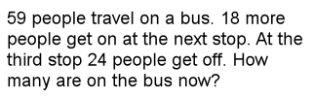 | Pupils practise addition, subtraction, multiplication and division for larger numbers, using the formal written methods of columnar addition and subtraction, short and long multiplication, and short and long division | Inclusive of decimals where appropriate.

