 | National Curriculum Objective (Statutory) | By the end of the year, children should be able to… | National Curriculum Objective (Non- statutory) | Example
3 | Write and calculate mathematical statements for multiplication using the multiplication tables that they know, including for two-digit numbers times one-digit numbers, using mental and progressing to formal written methods | 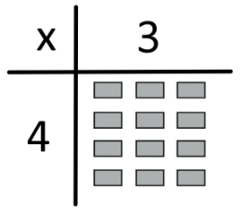  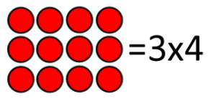  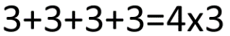  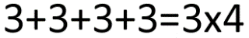  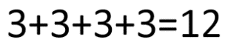 | Pupils develop reliable written methods for multiplication, starting with calculations of two-digit numbers by one-digit numbers and progressing to the formal written methods of short multiplication
4 | Multiply two-digit and three-digit numbers by a one-digit number using formal written layout  Guidance:  Ensure children have a secure foundation of multiplying parts of a number with grid method and use as teaching tool alongside introducing formal methods.  Expectation to be fluent in multiplying using column method. Note: numbers carried to the top (as opposed to bottom in addition) to allow for TO x TO calculations to exchange. | NB: Children should cross off exchanged numbers as they complete the calculation.  Numbers exchanged to the top when multiplying.  Numbers exchanged to the bottom when adding. | Pupils practise to become fluent in the formal written method of short multiplication
5 | Multiply numbers up to 4 Spriodigits by a one- or two-digit number using a formal written method, including long multiplication for two-digit numbers | NB: Children should cross off exchanged numbers as they complete the calculation.  Numbers exchanged to the top when multiplying.  Numbers exchanged to the bottom when adding. | Pupils practise and extend their use of the formal written methods of short multiplication | Children become fluent with using multiplication methods and start to multiply decimal numbers by adjusting to use whole numbers and readjusting to add decimal points back into answers.
6 | Multiply multi-digit numbers up to 4 digits by a two-digit whole number using the formal written method of long multiplication | NB: Children should cross off exchanged numbers as they complete the calculation.  Numbers exchanged to the top when multiplying.  Numbers exchanged to the bottom when adding. | Pupils practise multiplication for larger numbers, using the formal written methods of short and long multiplication | Extend to use larger numbers and continued work with decimal numbers.

